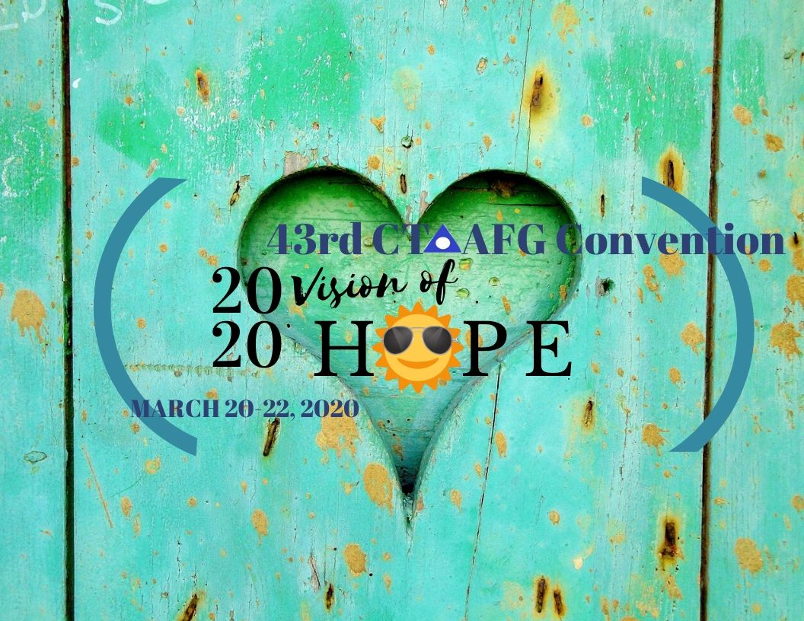

Are you looking for a service opportunity?

JOIN THE CT AFG CONVENTION COMMITTEE
POSITIONS AVAILABLE

FLYERS CHAIR/CO-CHAIR
PROPERTIES CO-CHAIR
TREASURER CO-CHAIR

Questions or for more information email: Convention2020@ctalanon.org
JOIN US AT THE NEXT CONVENTION PLANNING MEETING

March 15, 2020
United Methodist Church
401 New Britain Ave., Newington, CT
1:00-Stuffing Party
2:00-4:00 Meeting

