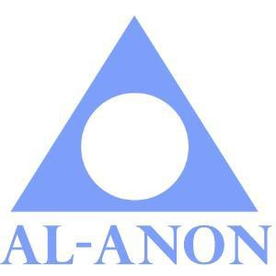 **CONNECTICUT AWSC ASSEMBLY**

**DREAM BIG WITH 20/20 VISION**

**AGENDA**

**JUNE 13, 2020 12: 15 pm**

***DR & Alt. DR Workshop 10:30-11:30 a.m. Pat. S.***

Opening Prayer 12:15 p.m. Elaine M.

Welcome Elaine M.

Roll Call Taffy P.

Opening Remarks/Announcements Elaine M.

Secretary’s Report Taffy P.

Treasurer’s Report Jackie B.

Alt. Delegate’s Report Pat S.

Fall Assembly 2019 Report District 4 & 5 (3 min.)

Delegate’s Report Marcia M.

**Break – 10 minutes**

|  |  |
| --- | --- |
| **Reports: (3 minutes each)**  Alateen Coordinator - Lisa G.  Archives - June C.  Board of Directors - Deborah C.  Convention 2020/2021 - Rick L. & Martha N.  Group Records - Kelly D.  LDC Finance Chair - Ron S.  Literature Coordinator – Morgan R.  Public Outreach - Kathe L-B.  **Closing: Al-Anon Declaration** | **Notes:** |

* Please remember to bring your Service Manuals.
* If you are on the Agenda and unable make it, please try to send a substitute or contact both the chair and secretary.
* If you are presenting a report, please send an electronic copy to the Area Secretary and Website Coordinator by Thursday, June 11, 2020.

**Upcoming Dates to Remember**

|  |  |  |  |
| --- | --- | --- | --- |
| **August 7, 2020** | **AWSC Budget Meeting** | | |
| **September 11, 2020**  **AWSC** | **District Reports -**  **Districts 1 & 2** | **Concept 9 –**  **District 11** | **Refreshments –**  **District 7** |